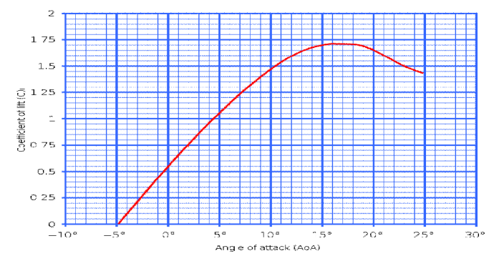

DEPARTMENT OF AERONAUTICAL ENGINEERING

AE8501 - FLIGHT DYNAMICS
TWO MARKS QUESTION WITH ANSWER
UNIT I

Enumerate the conditions of minimum drag minimum power?(Apr/May 17 ‘’ & Nov/Dec 16” R13)
  - Maximum L/D, minimum TR and minimum D.
  - Thrust Required TR must be proportional to 1/(L/D) or 1/(CL/CD)

Plot the variation of C_{L} And angle of attack and indicate the effect of aspect ratio on this curve? (Apr/May 17 ‘’ R13)

- Define drag polar.(Apr/May 17” R08)
The Drag Polar is the relationship between the lift on an aircraft and its drag, expressed in terms of the dependence of the lift coefficient on the drag coefficient.

What is the difference between the profile drag and pressure drag? (Nov/dec 16” R08/10)
profile drag |  |  |  |  | pressure drag
Profile drag is the drag incurred |  |  |  |  | The drag due to imbalance in the drag  caused by separated flow. | pressure  direction
from | frictional | resistance | of | the |  | pressure  direction
blades passing through the air. It
does not change significantly with
angle of attack of the airfoil section,
but increases moderately as airspeed
increases.

- Why does SFC vary with velocity and altitudes?
The value of TSFC for a given engine will vary with speed and altitude, because the efficiency of the engine changes with atmospheric conditions.

Define skin friction drag and pressure drag? (Nov/Dec 16 R13)

Skin friction drag
Drag due to frictional shear stress integrated over the surface.

Pressure drag
The drag due to pressure imbalance in the drag direction caused by separated flow.

What causes induced drag? (Nov/Dec 16” R13)
The pressure drag due to pressure imbalance in the drag direction caused by the induced flow (downwash) associated with the vortices created at the tips of finite wings.

Define SFC and TSFC. (Nov/Dec 16 R13 & May/June16 R13)
SFC
Ratio of fuel consumption per unit time (in Kg/hr) to power produced by engine (in kWh) Specific fuel Consumption = Fuel consume per unit time / power produced TSFC
The fuel efficiency of an engine design with respect to thrust output.

What is the significance of drag divergence Mach number? (Nov/Dec 16 R13)

The drag divergence Mach number is the Mach number at which the aerodynamic drag on an airfoil or airframe begins to increase rapidly as the Mach number continues to increase. This increase can cause the drag coefficient to rise to more than ten times its low speed value.

What is the need to define ISA and give its values at standard sea level condition?
Since atmospheric conditions like pressure, temperature and density are constantly varying with altitude and location of the earth surface, there is a need for a normal atmosphere to use it as standard for the design and flight evaluation of aircraft all over the world. Its standard sea level values are, pressure = 1.013 x105 N/m2, temperature =288K, and density =1.225 kg/m3

What are the factors which decide the flying path of an airplane as a rigid body?
Airplane as a rigid body its flying path is decided by ,
- Its inertia characteristic.
- Earth‘s acceleration due to gravity
- Propulsive force generated by power plant
- Aerodynamic forces (L&D) and moments created on it due to the reaction between airplane and air.

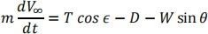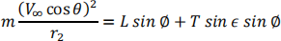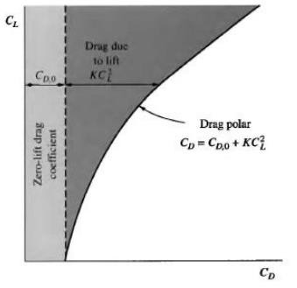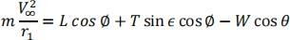

Write down the major differences between the turboprop and turbojet engines in generating the propulsive power
In airplanes using turbo propeller system, out of total useful work done to propel the airplane, 80-95% is derived from the propeller and the reminder only from the exhaust jet reaction. In typical turboprop system, power (P= TV) is nearly constant and hence thrust (T) decreases as speed (V) increases. In turbojet propulsion system, the total useful work done to propel the airplane is produced by the expansion of the combustion gases through exhaust nozzle. Thrust is made nearly constant by increasing the mass flow rate (kg/s) at high speed (V).

What are the different power plants used in airplanes? Which power plant is most efficient for subsonic airplanes?
Latest power plants used in airplanes include; propeller driven by reciprocating engines as well as turbines, turbojets, ramjet and rockets. Here other than rockets all other power plants are using air-breathing engines. Turbojet power plants are most efficient for subsonic airplanes compared to Turboprop, ramjet and rockets. Ramjet and rockets are efficient for short duration supersonic flights whereas turbo propellers are less efficient and can be used only at low speed.

What are the conditions required for maximum drag and minimum power?
Maximum drag occurs when the angle of attack exceeds the critical angle of attack and the speed approaches the stalling speed. The left hand limit of PR versus Vcurve shows the stalling speed corresponding to maximum lift (CLmax) and maximum drag. Minimum power occurs at the speed at which total power(PR) is minimum .This occurs when parasite drag is 1/3 of induced drag .In drag coefficient form, CDf = 1/3(CL**2/ Ae).

Draw the drag polar curves of the airplane.

- Write down the equation of motion of the three dimensional translational flight.

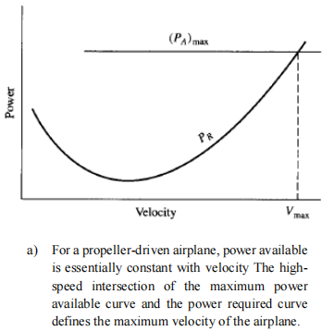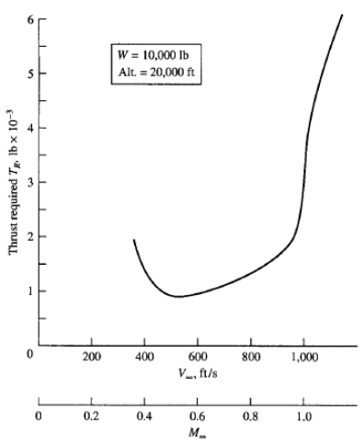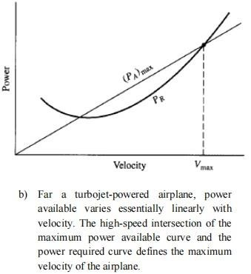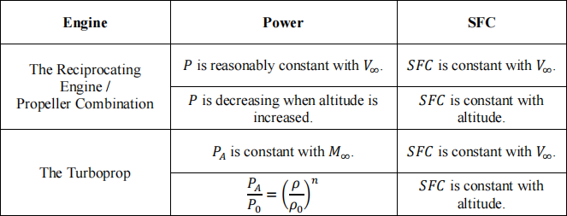

Plot the Thrust required curve.

- To draw the max velocity of propeller driven airplane.

To draw the max velocity of turbojet powered airplane.

- Write down the variations power & specific fuel consumption with velocity & altitude.

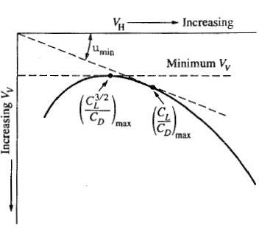

UNIT II

- What are the significance of V-n diagram(Apr/May 17 ‘’ R13)
A chart of velocity versus load factor (or V-n diagram) is another way of showing limits of aircraft performance. It shows how much load factor can be safely achieved at different airspeeds.

Define absolute ceiling and service ceiling(Apr/May 17 ‘’ R13 &Nov/Dec 16 R13 &Nov/Dec15 R13)
The system of PR and PA versus V curves, both at sea level and altitude are fundamental in determining climb and decent performance of airplane. Minimum and maximum speeds (absolute ceilings) are determined by the intersection of the two curves (PR and PA) taken for the same altitude. Any speed between the maximum and minimum ceiling speeds can be the service speed. Sometimes in altitude flight, the minimum speed will be higher than the stalling speed and hence the stalling speed cannot be achieved in level continuous flight.

What are constraints on load factor of an airplane? (Apr/May 17” R08) Limit load factor:
n=1 it will return to its original state
n is less than the limit load factor, the structure may deflect during a maneuver
n is greater than the limit load factor, then the airplane structure will experience a permanent deformation, that is it will incur structural damage

Ultimate load factor:
This is the boundary associated with outright structural failure. If n is greater than the ultimate load factor, parts of the airplane will break.

Sketch the hodograph diagram for unpowered flight. (Apr/May 17” R08)

- Define time to climb.(Nov/dec 16” R08/10)
The vertical component of the airplane’s velocity, which is simply the time rate of change of altitude dh/dt.
dh/dt=R/C

Define V-n diagram & Load factor. (Nov/dec 16” R08/10)
A chart of velocity versus load factor (or V-n diagram) is another way of showing limits of aircraft performance.
Forces acting on an aircraft during a level coordinated turn. Load factor is a very important structural design parameter of an aircraft, as it indicates the amount of the load which the structure of an aircraft can bear. For this reason, maximum load factor is a maneuvering and performance limit.

What do you meant by limitations of pull up and push over?

The pilot suddenly pitches the airplane to a higher angle of attack such that the lift suddenly increases, because L>W the airplane arch upward. The flight path becomes curved in the vertical plane, with a turn radius R and turn rate dθ/dt. This is called the pull up maneuvers.
Push-Over is the action of an aircraft, whose propeller thrust line is above the Center of Gravity and lacks an adequate horizontal stabilizer to pitch forward.

Define range and endurance.(May/June16 R13)

Range is the total distance traveled by an airplane on one load of fuel.

Endurance is the amount of time that an airplane can stay in the air on one load of fuel.

What is the significance of load factor? (May/June16 R13 &Nov/Dec 16 R13)
Load factor (n) is defined as the lift (L) divided by the weight (W) at the stalling speed corresponding to CLmax .
Any attempt to increase the lift by further increasing the angle of attack will result in the reduction of CL and increase of CD . This will result in increase of thrust required to maintain the flight at lower speed . Hence a load factor of 1, at CLmax, only feasible provided enough power is available.

What is the condition for minimum rate sink and shallow angle for powerless gliding flight? (Nov/Dec15 R13)
  - For maximum range, we must operate at the maximum L/D condition (minimum drag)
  - For maximum endurance (minimum sink rate) we must operate at the minimum power require condition.

Define Load factor
The chart of velocity versus load factor is another way of showing limits of aircraft performance. Force acting on a airplane during a level coordinated turn. Load factor is very important structural design parameter of an aircraft, as it indicates the

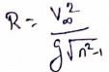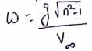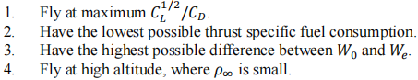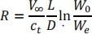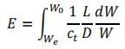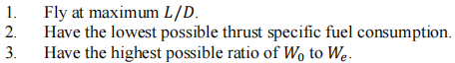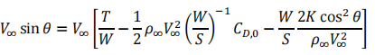
amount of load which the structure of aircraft can bear. For this reason, for max load factor is a maneuvering & performance limit.

Write down the brequet range equation.

W₀- Gross weight of the airplane
W_{e}- Weight of the airplane where the fuel is empty

What are the influences to calculating the range.
  - Lift to drag ratio
  - Specific fuel consumption
  - Velocity
  - Initial amount of fuel

Write down the Endurance equation of the airplane.

- What are the flight conditions for maximum range for a jet propelled airplane.

What are the flight conditions for maximum endurance for a jet propelled airplane.

- Write down the equation of climbing performance of an airplane.

Write down the equation of turn radius & turn rate.

- What is the condition for Rmin for turning an airplane in level flight? Also give the time (t) for 3600 turn in terms of V and tanø (ø-turning or yawing angle).
Considering the turning banking angle as ø, tan ø= V2/R.g, ie ; R = V2/g tan ø
For Rmin;
- V should be small, approaching to Vstall.
- tan ø should be high . Time for 3600 turn (t) = 2 R/V =2 V/g tan ø.

What are the flight conditions for maximum endurance for a propelled driven airplane?
  - Fly at maximum C ^{3/2} / C
L D
  - Have a highest possible propeller efficiency
  - Have a lowest possible specific fuel consumption
  - Have a highest possible difference between W₀ & W_{e}

UNIT III

- Define static margin. (Apr/May 17 ‘’ R13)
Static margin is defined as the distance between the center of gravity and the neutral point of the aircraft, expressed as a percentage of the mean aerodynamic chord of the wing.

What is meant by degree of freedom and how much required for an airplane? (Apr/May 17 ‘’ R13 & May/june 16 R13) (Apr/May 17” R08)
The freedom of movement of a rigid body in three dimensional spaces. Specifically, the body is free to change position as forward/backward (surge), up/down (heave), left/right (sway) translation in three perpendicular axes, combined with changes in orientation through rotation about three perpendicular axes, often termed yaw (normal axis), pitch (lateral axis), and roll (longitudinal axis).

What are the two conditions for static longitudinal stability? (Apr/May 17” R08)

The stability of an aircraft in the longitudinal,or pitching, plane under steady flight conditions. A human pilot will be able to control the aircraft in the pitching plane without requiring excessive attention or excessive strength

What is the need for aerodynamic balancing of a control surface? (Nov/Dec 16” R08/10)
A means of reducing the hinge movement and thereby the physical effort needed to control an aircraft. ..... Some form of aerodynamic balancing is required to assist the pilot to move controls easily in the absence of power-assisted controls.

What is neutral point? What it its signicance? (Nov/Dec 16” R08/10& May/June 16 R13 &(Nov/Dec 16 R13)
A mathematical analysis of the longitudinal static stability of a complete aircraft (including horizontal stabilizer) yields the position of center of gravity at which stability is neutral. This position is called the neutral point.

What do you meant by inherently stable and marginal stable airplanes? (Nov/Dec 16 R13 &Nov/Dec15 R13)
Inherent stability is the tendency of an aircraft to return to straight and level flight, when the controls are released by the pilot. Most aircraft are designed with this in mind and are said to be "inherently stable."
Marginally stable system is when the system control components are JUST right. So if they change slightly the system becomes unstable. So wouldn't fly on that airplane.

State any two basic requirements of aircraft control surface? (Nov/Dec15 R13)
Aircraft flight control surfaces are aerodynamic devices allowing a pilot to adjust and control the aircraft's flight attitude.
Movement of any of the primary flight controls causes the aircraft to rotate around the axis of rotation associated with the control surface.

What is the criterion for static longitudinal stability?
For static longitudinal stability of the airplane (AP) the overall value of (dCm/dCL) AP 0. This rate of change of coefficient of moment about Yaxis (dCm) with respect to the change in lift coefficient (dCL) is the summation of similar values contributed by different parts of airplane, like wing, fuselage, engine power, tail/elevator etc. Some of them are positive and others are negative. The cumulative effect should be such that overall value should be negative (ie; (dCm/dCL)total 0).

State two contributions for static longitudinal stability and indicate them with a plot.
In Cm versus CL plot indicate the longitudinal stability contributions of wing and fuselage, tail alone and the total for airplane. If the total longitudinal stability which is the sum of individual contributions is negative (dCm/dCL) then the airplane will be stable.

define wing`s vortex system with figure.
Wing`s vortex system can be represented as shown in figure, consisting of bound vortex ` located at the wing quarter chord (0.25 c) and a vortex sheet streaming from the wing trailing edge, which will roll up to form the familiar two trailing vortices . The wing wake center line which is in the vortex sheet is displaced downward and deformed by the influence of the bound vortex and the powerful trailing vortices. The strength of the vortex system is proportional to the CL therefore the downwash (€) at any particular point will be Proportional to CL ie; € = f( CL).

Define elevator power and write down the elevator power criterion equation
The magnitude of pitching moment coefficient, Cm, obtained per degree deflection of the elevator is termed as the elevator power .It is the derivative of Cm w.r.t elevator deflection (dCm/d e =Cm) The elevator power criterion is mentioned below dCm/d e =Cm

What are the major contributions of the indirect effects of the running propellers on the static longitudinal stability?
There are 4 major contributions making up the indirect effects of the running propellers on static longitudinal stability. They are the effects of slip stream created by propeller on the following:
  - effect of slipstream on wing-fuselage moments
  - effect of slipstream on wing lift coefficient (CL)
  - effect of slipstream downwash at the horizontal tail
  - effect of increased slipstream dynamic pressure (q) on the tail.

What are the two major effects of the running propeller that contribute to the longitudinal stability and define them?
Two major effects are (1) Direct propeller contribution arising as a result of the forces created by the propeller itself. (2) Indirect effects which arises as the result of the slip stream from the propeller and its interaction with the wing and tail surfaces Propeller forces, both thrust (T) and normal force (Np) create moments about c.g of the airplane and hence they have stability contribution (dCmp/dCL) which influence the overall static longitudinal stability.

What is a tab and how it is effective?
Tab is a control surface and is an auxillary flap usually built into the trailing edge of the main control surface. Because of its location, it can create very powerful moments about the control surface hinge line. It is used as a trimming device, a balancing device and in some cases as a primary control surface.

Define stick-fixed maneuvering point (Nm) and stick- free maneuvering point (Nm`)
If the c.g is moved aft behind (No) and (No`), the stability in accelerated flight will be reduced until at some c.g position the change in elevator angle and the stick force (Fs) required to accelerate flight will be zero. These c.g`s are termed as the maneuvering points .The c.g where the elevator angle (e) required to accelerate the airplane vanishes is the stick- fixed maneuvering point (Nm) and the c.g where Fs required to accelerate the airplane vanishes is the stick- free maneuvering point (Nm`) .

Define stick- free maneuver point (Nm`) and where it is located with reference to neutral point at stick -free (No`)
The gradient of the stick force (dFs /dn) do not vanish at stick -free neutral point (at (dCm/dCL) free =0) but shows that, if c.g is moved sufficiently aft of No`, a position will reach where dFs/dn =0. This c.g position is termed as stick-free maneuver point (Nm`).

What is the criterion for longitudinal stability and control in maneuvering flight?
The increment of elevator angle ( e) and stick force ( Fs) to produce an increment in normal acceleration equal to 1g at constant speed ,both in pullups and in

steady turn is the criterion for longitudinal stability and control in maneuvering flight . That is (d e /dn) and (dFs/dn) are criterion.

What are the two important maneuvering flights and their essential requirements?
Flight in curved paths are called maneuvering flight . Two important maneuvering flights (a) that taking place in vertical plane passing through the plane symmetry of air plane called pull-up maneuvering (b) that taking place in horizontal plane called normal turn. In (a) , the net upward force (L-W) act as the pull-up force perpendicular to the curved path .In (b) the resultant of lift vector in the horizontal plane perpendicular to the flight path act as the centripetal force.

What are the commonly used gadgetries for improving stick force gradient?
There are a few new devices now available for giving constant pull force on the stick . The most common of them are the down spring and bob weight, vee tab or spring tab. The down spring and bob weight are not very effective in ground operation where as the spring tabs are more efficient in giving a constant torque about the hinge line of the elevator.

What is the restriction on the aft c.g imposed by the stick-free neutral point (No`)?
The concept of stick-free neutral point (No`) is that c.g location where (dCm/dCL) free = 0 or where dFs/dV = 0 through trim speed where Fs=0. This brings a new restriction on the aft limit of the allowable c.g range.
At present the Army and Navy call only for the most aft c.g to be ahead Of the stick-free neutral point (No`). (Show the new aft limit of c.g (No`) and usable c.g range in a figure usually used)

UNIT IV

- Define rudder lock. (Apr/May 17 R13)

Occasionally an airplane will exhibit characteristics called ‘rudder locks ‘where the force on the rudder pedals suddenly reverse as the rudder deflection approaches its maximum deflection. The rudder will tend to float all the way to the maximum deflection without any effort by the pilot.

This is a potentially dangerous situation for a multi engine airplane, where the loss of one engine will require large amount of rudder deflection, to maintain straight level flight.

What is aerodynamic balancing of an air plane? (Apr/May 17” R13)
A means of reducing the hinge movement and thereby the physical effort needed to control an aircraft. ... The most common forms of aerodynamic balancing are inset hinges, horn balances, internal balances, and tab balances.

The ways and means of reducing of magnitudes of C_{hαt} and C_{hδe} are called aerodynamic balancing.

Define dihedral effect(Apr/May 17” R08 & R08/10)
Dihedral effect is the amount of roll moment produced per degree (or radian) of sideslip. Dihedral effect is a critical factor in the stability of an aircraft about the roll axis (the spiral mode). It is also pertinent to the nature of an aircraft's Dutch roll oscillation and to maneuverability about the roll axis.

What is weather cock stability of an airplane? (Apr/May 17” R08 & R08-10 & R08 & Nov/Dec15 R13)
An aircraft is directionally stable if when it is temporarily deflected from its course, it tends to return to the original course without any correction applied by the pilot. Also called weathercock stability or yaw stability.

What is meant by adverse law?
Adverse yaw is the natural and undesirable tendency for an aircraft to yaw in the opposite direction of a roll.

What is aileron reversal?
A situation occurs at some high speed when the moment is so large that there is total loss of lift when the aileron is deflected downward, and the aircraft rolls in the reverse direction. This is called aileron reversal. An adverse effect when an aircraft rolls in the reverse direction of the aileron input.

What are the advantages of sideslip?

Sideslip can be used (a) to increase the airplane drag and thereby its flight path angle during an approach for landing, (b) useful in getting smooth aerobatics such as slow rolls and (c ) finally it can help during flight with asymmetric power.

What is meant by dihedral and anhedral? (May/June 16 R13)
Dihedral angle is the upward angle from horizontal of the wings or tail plane of a fixed- wing aircraft.
"Anhedral angle" is the name given to negative dihedral angle, that is, when there is a downward angle from horizontal of the wings or tailplane of a fixed-wing aircraft.

State the two basic requirements of the rudder. (Nov/Dec 16 R13)
Asymmetric power
The critical asymmetric power condition occurs for a multiengine airplane condition when one engine fails at low flight speeds. The rudder must be able to overcome the yawing moment produced by the asymmetric thrust arrangement.
Spin recovery

The primary control for spin recovery in many airplanes is a powerful rudder.
The rudder must be powerful enough to oppose the sin rotation.

What is adverse yaw effects and how it is controlled by rudder? (Nov/Dec 16 R13 & Nov/Dec15 R13)
On large aircraft where rudder use is inappropriate at high speeds or ailerons are too small at low speeds, roll spoilers (also called spoilerons) can be used to minimize adverse yaw or increase roll moment.
This will counter the drag produced by the other aileron, thus reducing adverse yaw. Unfortunately, as well as reducing adverse yaw, Frise ailerons will increase the overall drag of the aircraft much more than applying rudder correction.

Define rudder power and how it is related to directional stability of airplane.
The rate of change of yawing moment coefficient (dCn) per degree change in rudder angle (d r) is called the rudder power. That is equal to dCn/ d r or Cn r. The directional stability of airplane is dCn/d = Cn . If Cn r = -0.001 and Cn=0.001, it can be seen that 10 of rudder will produce 10 of yaw.

How rudder power is estimated?
Rudder power to overcome the adverse yawing moment (Cn)tail is estimated using wind-tunnel model test data .The adverse yawing moment coefficient due to rolling of the wing (Cn)roll can be estimated theoretically . So the rudder power required to overcome adverse yaw can be expressed as follows: dCn/d r =Cn r = ((Cn)roll +(Cn)tail )/ rudder throw (=300) .

What is the concern of the designer to keep the pedal force required within suitable practicable values?
A fighter airplane climbing at full throttle (power) at 288 km/hr may push over to a dive up to 720 km/hr speed. If the airplane is trimmed out directionally at climb, the pilot may have to exert a PF as high as 92 kgf to maintain zero sideslip in the dive. Hence it is essential for the designer to keep the pedal force changes with speed as low as possible by suitable aerodynamic balance.

How to avoid rudder lock?
Rudder lock can be avoided by two ways; 1) To cut down the rudder effectiveness (d v /d r ), thereby increasing the rreqd at a given sideslip. (2)Another way is to provide a dorsal fin which increases the fuselage stability at high as well as reduces the tendency of the vertical tail to stall.

What is the relation for the greatest of pedal force (PF) with respect to sideslip and give its accepted value?
The greatest of pedal force (PF) w.r.t to sideslip ( ) can be derived as dPF/d = (G q v Sr Cr Ch r /Cn r ) *(Cn )free ,where (Cn )free = (Cn )fix - (Ch v .Cn r) / Ch r . It

shows that dPF/d varies with V2 for normal aerodynamic balance. A criterion of 2.25 kgf/deg of sideslip at 240 km/hr speed has been taken as the minimum for this gradient.

What is the criterion to keep the directional stability with stick-free above certain limit or not to lose much?
For high speed airplanes which require close aerodynamic balance of rudder and hence the rudder pedal force to be applied by the pilot should be within practicable limit. So it is essential that the ratio of derivative of H.M coefficient with tail angle of attack (v) and rudder power (Ch r) should be kept low so as not to lose too much directional stability with stick-free.

How the floating rudder (stick-free) affects the directional stability?
When rudder is left free to float in response to its hinge moment, it can have large effects on the directional stability. It is in the similar way, the floating elevator affects the longitudinal stability. When the airplane sideslips, the restoring moment due to the tail will be decreased if the rudder floats with the wind and will be increased if it floats against the wind. The floating rudder changes the effective angle of attack of the total vertical tail.

What are the flight conditions or maneuvers that produce unbalance yawing moments those are to be overcome by rudder?
One is (a) the adverse yaw moment, which happens due to turn during normal flight (b) slipstream rotation; the slip stream behind the propeller has rotational components which changes the angle of attack on the vertical tail ( v ) and create sideslip
.This is critical at high power - low speed flight. Cross wind during take-off and landing.
(d) Spinning recovery by rudder (e) ant symmetric power flight, when one of the multi- engines of airplane fails.

How the total directional stability contributions of parts of airplane is made more stabilizing?
Sum of the directional stability contributions of wings, fuselage and propeller and that of their interference effects will usually give an unstable effect. Hence an additional stabilizing surface must be incorporated not only to overcome the instability but also to give the desired level of directional stability. This stabilizing surface is the normal vertical tail placed as far aft of the c.g of airplane as practicable.

What is the requirement of directional control - rudder?
Although the airplane will normally be in equilibrium at zero sideslip there are many maneuvers that introduce yawing moments which are to be opposed by some yawing moment control (directional control) to achieve zero sideslip. This yawing moment control is supplied by pilot by means of a rudder, normally a plane flap attached to the aft portion of the vertical tail.

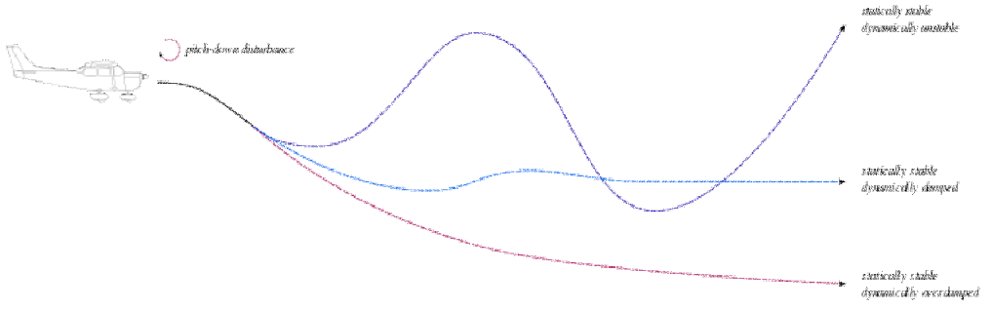

UNIT V

- Represent the system that is statically stable but dynamically unstable. (Apr/May 17 ‘’ R13)

An aircraft can show static stability but the resulting dynamic stability can be positive, neutral and even negative. ... In a dynamically unstable but a statically stable aircraft, just like in other situations the aircraft tries to return to equilibrium.
But the amplitude of oscillations increases with time.

What are the parameters that effect phugoid mode? (Apr/May 17 ‘’ R13)

The period of time required for one complete oscillation, the time required to damp to half-amplitude, or the time to double the amplitude for a dynamically unstable motion

What are the characteristic modes of stick fixed longitudinal motion of airplane? (Apr/May 17” R08 & May/june 16 R13)
  - Phugoid (longer period) oscillations
  - Short period oscillations
  - Roll subsidence mode
  - Dutch roll mode
  - Spiraling

Define spin of an aircraft.
A spin is a special category of stall resulting in autorotation about the vertical axis and a shallow, rotating, downward path. Spins can be entered intentionally or unintentionally, from any flight attitude if the aircraft has sufficient yaw while at the stall point.

What are difference between directional stability and dynamic stability? (Nov/dec 16” R08/10)
Directional stability is stability of a moving body or vehicle about an axis which is perpendicular to its direction of motion.
Dynamic stability describes the form of motion an aircraft in static stability undergoes when it tries to return to its original position.

Define snaking mode.

A control mode in which the pursuing aircraft flies a programmed weaving flight path to allow time to accomplish identification functions.

Distinguish between stability and controllability? (May/june 16 R13)

Stability and control characteristics of an AP are called flying qualities. Stability is the property of an equilibrium state and it is divided into static and dynamic stability. Static stability is the tendency of the AP to return to its equilibrium after a disturbance. In dynamic stability, the vehicle's motion with the time after it is disturbed from its equilibrium point is considered.
Controllability of a system is related to its ability to transfer control requirements. A system is controllable if it transfers any initial state Xi(t) to any final state Xf(t) in finite time.

What is auto rotation?

When the wing's are stalled; ie; beyond the critical angle of attack (cr) , the rising wing will have higher CL than the falling wing .This creates an unbalanced couple about X-axis to rotate (roll) further which is called autorotation. Rolling occurring in the almost horizontal plane is also a form of autorotation.

Define dutch roll and its effects?(Nov/Dec 16 R13)
Dutch roll is a type of aircraft motion, consisting of an out-of- phase combination of "tail-wagging" and rocking from side to side.

What is meant by spiral divergence? (Nov/Dec15 R13)

An aircraft may or may not have inherent static stability in roll. Most aircraft are slightly unstable in roll, both statically and dynamically. Such instability is known as spiral divergence.

What are stability derivatives? (Nov/Dec15 R13)
-C_{lβ} - rolling moment due to sideslip
-C_{lp} - rolling moment due roll rate
+C_{nβ} – yawing moment due to sideslip C – coefficient
L – roll moment β – side slip angle

How to get out of the spin smoothly?
In order to get out of a spin we must get out of the stalled (CLmax) state by putting the nose down (reduce) and also we must stop rotation by applying `opposite rudder’. In practice the roll is stopped first, because it is found the elevators are not effective (to change) until the rotation is stopped.

What is proposing mode of dynamic motion?

The damping of long period mode (phugoid mode) can become very weak under certain design conditions and can become neutrally damped or even unstable. This mode when neutrally damped is usually called proposing. Such modes have occurred in high speed airplanes, in which the oscillations of normal acceleration become so severe that the pilot was injured seriously and airplane damaged before the pilot could stop the oscillation by slowing down.

Why the study on dynamic characteristics of the airplane is necessary?
In order to understand the requirements for static stability and control, it is necessary to study the dynamic characteristics of the airplane. It is done by investigating the types of motions of the airplane in response to a disturbance from some equilibrium flight condition and the nature of transient motions of the airplane in response to the movement of its controls.

What way the dynamic stability analysis of the airplane helps the design of control systems and the pilot who operates it?
If the motion of the airplane in response to some disturbance is very slow divergence, the control requirements are different from those needed if the divergence is extremely rapid. The ability of the pilot to react and apply the controls is a factor which must be kept in mind for all studies of airplane dynamics. The design of controls and the ability of the pilot to apply controls in time, requires some knowledge of the transient response of the airplane to a disturbance or to controls.

What are the 4- different modes of motion of a dynamic system when responding to a disturbance from an equilibrium position?
Dynamic system in general has 4- different modes of motion when responding to a disturbance from its equilibrium position. They are a periodic and oscillatory modes with and without damping. That is a periodic can be pure convergence if the motion is damped (stable) and divergence if undamped (unstable) .Similarly oscillatory motions (periodic ) can be damped oscillation (stable) or undamped oscillation (unstable).

What are the six degrees of motion of a dynamic system and how it is formed for the airplane?
According to the Newtonian laws of motion which states that (a) the sum of all external forces in any direction must be equal to the time rate of change of momentum, and (b) the sum of all external moments of forces must be equal to the time rate of change of moment of momentum, all measured w,r,t axes fixed in space . The six equations of motion are: Fx = m ax, Fy = m ay, Fz = m az , L = dHx /dt , M = dHy/dt , N = dHz /dt . (where `m` is the mass , ax, ay, az are linear accelerations and Fx , Fy , Fz are external forces and L, M, N are external moments of forces and Hx ,Hy , Hz are moments of momentum about X, Y, Z axes respectively.)

Briefly explain the stability derivatives, Clp and Cnr.

The derivatives Clp and Cnr are the damping derivatives in roll and yaw respectively; whereas the derivatives Clr and Cnp are usually referred to as the rotary or cross derivative. They are the rolling moment (Cl) due to yawing velocity (r) and yawing moment (Cn) due to rolling velocity (p).

Explain the term stability derivatives.
For the analysis of dynamic characteristics (Modes of motion) of AP either in longitudinal or lateral direction, respective simultaneous homogenous differential equations are to be developed. The constant coefficients of these equations are made up of AP mass and inert parameters and so called stability derivatives, like CL, CD and Cm. CL = dCL / d which is the slope of the lift curve with respect to angle of attack. Cm = (dCm / dCL)(dCL / d ) = (dCL / d ) (S.L.S) criteria.

How many degrees of freedom are there for lateral dynamic motion and what are they?
There are 5- degrees of freedom for the lateral dynamic motion, because there are two lateral controls; the rudder and aileron. The five degrees of freedom are: a) Velocity along the Y -axis (b) rotation about X- axis (c) rotation about Z-axis (d) rotation of rudder about its hinge (e) rotation of aileron about its hinge.

